SIMATS ENGINEERING
ASSESSMENT TOOL 3

COURSE NAME: OBJECT ORIENTED ANALYSIS AND DESIGN
COURSE CODE: CSA1102

COURSE OUTCOME COVERED

CO5: Analyze object-oriented software using quality assurance and usability testing techniques. ( BL4,BL5)
Assessment Tool Weightage: 40%

QUESTIONS: 05 Total Marks:40

Annexure A

MOCK INTERVIEW

Code of Conduct:

I N.Nesarajan/192511386(Name / Reg No) certify that this submission is my original work and that I have adhered to the guidelines specified for this assessment.
I understand that any violation of academic integrity rules will result in disciplinary action.

Signature of the student:

Annexure A

Mock Interview – Sample Questions (5 Questions)
Mock Interview Test Format for Object Oriented Analysis and Design (OOAD)

Section A Self Introduction & Fundamentals 3 Minutes 5
Section B Technical Questions (OOAD Concepts) 7 Minutes 10
Section C UML Modeling & Design 7 Minutes 10
Section D Case Study / Problem Solving 8 Minutes 10
Section E HR & Career-Oriented Questions 5 Minutes 5

SECTION A – SELF INTRODUCTION (5 Marks)

Evaluation Criteria
- Communication Skills
- Confidence
- Technical Awareness
- Academic Background

Sample Questions
- Tell me about yourself.
- Why did you choose Computer Science?
- Explain your favorite subject in OOAD.
- What software development tools have you used?
- Describe a project where you applied object-oriented concepts.

SECTION B – TECHNICAL QUESTIONS (15 Marks)

Basic Level

Q1. What is Object-Oriented Analysis and Design?

Q2. Differentiate between Analysis and Design.

Q3. Explain Encapsulation with an example.

Q4. What is Inheritance? Mention its types.

Q5. Define Polymorphism and its benefits.

Q6. What is Abstraction?

Q7. Difference between Aggregation and Composition.

Q8. What is Coupling and Cohesion?

Q9. What is a Class and an Object?

Q10.Explain Object Responsibility.

SECTION C – UML MODELING (15 Marks)

Q11.What is UML?

Q12.When would you use a Use Case Diagram?

Q13.Draw and explain a Class Diagram for a Library Management System.

Q14.Differentiate Sequence Diagram and Activity Diagram.

ANSWERS

SECTION A – SELF INTRODUCTION

1. Tell me about yourself.

I am Nesa Rajan N, a Computer Science Engineering student with a strong passion for software architecture, object-oriented systems, and core programming. Throughout my academic journey, I have focused on building logical problem-solving skills and developing practical projects involving software design, databases, and system analysis.

2. Why did you choose Computer Science?

I chose Computer Science because it gives me the ability to convert abstract ideas into practical, scalable real-world applications. The logic behind system design, algorithms, and continuous technical evolution makes it both challenging and rewarding.

3. Explain your favorite subject in OOAD.

My favorite topic in OOAD is Unified Modeling Language (UML) structural design, specifically Class Diagrams and Design Patterns. Understanding how real-world entities are abstracted into classes, attributes, and relationships allows developers to build robust systems before writing a single line of code.

4. What software development tools have you used?
- Modeling Tools: StarUML, Visual Paradigm, Lucidchart
- IDEs & Compilers: Visual Studio Code, GCC Compiler
- Database Tools: MySQL Workbench
- Version Control: Git & GitHub

5. Describe a project where you applied object-oriented concepts.

I developed a modular software application where I applied core object-oriented principles. I used Abstraction to define clean module interfaces, Inheritance to create reusable entity structures, and Encapsulation to secure database and application state data across system modules.

SECTION B – TECHNICAL QUESTIONS

Q1. What is Object-Oriented Analysis and Design?

Object-Oriented Analysis and Design (OOAD) is a structured software engineering approach where a system is modeled as a collection of interacting objects.
- Object-Oriented Analysis (OOA): Focuses on understanding the problem domain and defining functional requirements in terms of real-world objects and use cases.
- Object-Oriented Design (OOD): Focuses on creating a technical solution by defining software classes, attributes, methods, relationships, and system architectures.

Q2. Differentiate between Analysis and Design.
Feature | Object-Oriented Analysis (OOA) | Object-Oriented Design (OOD)
Focus | Understanding what the system should do. | Deciding how the system will fulfill requirements.
Perspective | Problem domain / User requirements view. | Solution domain / Technical implementation view.
Artifacts | Use Case diagrams, Domain models. | Class diagrams, Sequence diagrams, Design Patterns.
Input/Output | Inputs: Requirements; Outputs: Conceptual Model. | Inputs: Conceptual Model; Outputs: Implementation Blueprints.

Q3. Explain Encapsulation with an example.

Encapsulation is the mechanism of wrapping data (variables) and code acting on the data (methods) together as a single unit, while restricting direct access to internal state details (data hiding).

Example:

C++

class BankAccount {

private:

double balance; // Private attribute protected from direct external modification

public:

void deposit(double amount) {

if (amount > 0) balance += amount;

}

double getBalance() {

return balance;

}

};

Q4. What is Inheritance? Mention its types.

Inheritance is the mechanism by which one class (subclass/derived class) acquires the properties (attributes) and behaviors (methods) of another class (superclass/base class), promoting code reusability.
- Types of Inheritance:
  - Single Inheritance: A child class inherits from one parent class.
  - Multilevel Inheritance: A class inherits from a child class (chain of inheritance).
  - Hierarchical Inheritance: Multiple child classes inherit from a single parent class.
  - Multiple Inheritance: A child class inherits from more than one parent class.
  - Hybrid Inheritance: A combination of two or more types of inheritance.

Q5. Define Polymorphism and its benefits.

Polymorphism (meaning "many forms") allows objects of different classes to respond to the same message or method call in their own specific way.
- Types:
  - Compile-time (Static): Method Overloading and Operator Overloading.
  - Run-time (Dynamic): Method Overriding using virtual functions or interface implementations.
- Benefits: Enhances code flexibility, extensibility, and reduces code redundancy.

Q6. What is Abstraction?

Abstraction is the process of hiding internal background implementation details and showing only the essential features of an object to the user. It simplifies system complexity by letting users interact with higher-level interfaces without worrying about low-level execution details.

Q7. Difference between Aggregation and Composition.
Parameter | Aggregation | Composition
Relationship | "Has-A" relationship (Weak association). | "Part-Of" relationship (Strong association).
Lifetime Dependence | Objects can exist independently of each other. | Child object cannot exist without the parent object.
Example | A Department has Professors. (If the Department closes, Professors still exist). | A Building has Rooms. (If the Building is destroyed, Rooms cease to exist).

Q8. What is Coupling and Cohesion?
- Coupling: Refers to the degree of interdependence between different software modules or classes. High coupling makes systems fragile and hard to maintain. (Goal: Low Coupling).
- Cohesion: Refers to the degree to which elements within a single module or class belong together and focus on a single responsibility. (Goal: High Cohesion).

Q9. What is a Class and an Object?
- Class: A user-defined logical blueprint or template that defines attributes (data) and methods (behavior) common to all objects of its type.
- Object: A concrete runtime instance of a class that holds state in memory and can perform operations defined by the class.

Q10. Explain Object Responsibility.

Object Responsibility defines the obligations of an object within a software system. Based on GRASP (General Responsibility Assignment Software Patterns), object responsibilities are categorized into two types:
- Doing Responsibilities: Performing an action, creating objects, or controlling calculations.
- Knowing Responsibilities: Knowing private data, related objects, or calculated references.

SECTION C – UML MODELING

Q11. What is UML?

Unified Modeling Language (UML) is a standardized, general-purpose modeling language used in software engineering to visualize, specify, construct, and document the structure and behavior of software systems.

Q12. When would you use a Use Case Diagram?

A Use Case Diagram is used during the requirement gathering and analysis phases of software development to:
- Identify system boundary and high-level scope.
- Identify external actors (users or external systems) interacting with the system.
- Model functional requirements and user goals visually.

Q13. Draw and explain a Class Diagram for a Library Management System.

Structure & Relationships:
- Book 1 ---- 0..* BookItem (Composition)
- User <--|-- Member, User <--|-- Librarian (Inheritance)
- Member 1 ---- 0..* Loan (Association)
- BookItem 1 ---- 0..* Loan (Association)

Class Representation:

Plaintext

+-----------------------+ +-----------------------+

| Book | | BookItem |

+-----------------------+ +-----------------------+

| - title: String | | - barcode: String |

| - author: String |1 * | - isAvailable: Bool |

| - ISBN: String |-------| |

+-----------------------+ +-----------------------+

| 1

+-----------------------+ |

| Member | | *

+-----------------------+ +-----------------------+

| - memberId: String | | Loan |

| - name: String |1 * +-----------------------+

| + issueBook() |-------| - issueDate: Date |

| + returnBook() | | - dueDate: Date |

+-----------------------+ +-----------------------+

Q14. Differentiate Sequence Diagram and Activity Diagram.
Feature | Sequence Diagram | Activity Diagram
Category | Interaction / Dynamic Diagram. | Behavioral Diagram.
Focus | Object interactions in a strict chronological time sequence. | Operational workflow and decision logic across operations.
Key Notation | Lifelines, Messages, Activation Bars. | Action States, Decision Nodes, Fork/Join Nodes.
Primary Use | Modeling detail execution of a specific use case. | Modeling high-level business logic or algorithmic flows.

Q15. Explain State Diagram with an example.

A State Diagram (Statechart) models the dynamic behavior of a single object by showing the sequence of states it transitions through during its lifecycle in response to external events.

Example (Online Order State Flow):

[Order Placed] --(Payment Success)--> [Processing] --(Shipped)--> [Out for Delivery] --(Delivered)--> [Closed]

Q16. What is a Deployment Diagram?

A Deployment Diagram is a structural UML diagram that models the physical deployment of software artifacts onto hardware runtime nodes (servers, devices, cloud infrastructure), showing hardware topology and network execution environments.

Q17. How do Component Diagrams help software architects?

Component Diagrams display how physical software modules (libraries, APIs, executables, microservices) are organized and wired together. Architects use them to:
- Verify high-level software modularity and architecture layout.
- Identify component dependencies and interface contracts (Provided and Required interfaces).
- Plan software builds, updates, and maintenance cycles.

Q18. What is Multiplicity in UML?

Multiplicity defines the numerical range of instances (cardinality) of one class that can be linked to a single instance of another class in a structural relationship.
- Notations:
  - 1 : Exactly one instance.
  - 0..1 : Zero or one instance (optional).
  - * or 0..* : Zero or many instances.
  - 1..* : One or many instances (at least one).

SECTION D – CASE STUDY / PROBLEM SOLVING

CASE STUDY 1: HOSPITAL MANAGEMENT SYSTEM

1. Identify the classes:

Hospital, Person (Abstract base), Doctor, Patient, Appointment, Billing.

2. Draw a simple class diagram (Text Representation):

Plaintext

+---------------------+ +---------------------+

| Doctor | | Patient |

+---------------------+ +---------------------+

| - doctorID: String | | - patientID: String |

| - specialization:Str| | - medicalHistory:Str|

+---------------------+ +---------------------+

| 1 | 1

| |

| 0..* | 0..*

+-------------------------------------------------------+

| Appointment |

+-------------------------------------------------------+

| - appointmentID: String |

| - date: Date |

| - time: String |

+-------------------------------------------------------+

| 1

|

| 1

+-------------------------------------------------------+

| Billing |

+-------------------------------------------------------+

| - billID: String |

| - amount: Double |

| + generateBill(): Void |

+-------------------------------------------------------+

3. Suggest relationships among classes:
- Doctor 1 ---- 0..* Appointment (Association)
- Patient 1 ---- 0..* Appointment (Association)
- Appointment 1 ---- 1 Billing (Composition - Bill depends on an appointment)
- Person <--|-- Doctor and Person <--|-- Patient (Inheritance)

4. Which UML diagrams would you use for analysis?
- Use Case Diagram: To outline functional interactions between Patients, Doctors, and Receptionists.
- Domain Model (Class Diagram): To establish fundamental conceptual business entities.
- Sequence Diagram: To analyze scenarios like booking an appointment or generating an invoice step-by-step.

5. Explain how inheritance can be applied:

Create an abstract general base class Person containing attributes like name, age, contactNo, and gender. Doctor and Patient classes inherit from Person, eliminating code duplication while allowing each subclass to declare specific attributes (e.g., specialization for Doctor, medicalHistory for Patient).

CASE STUDY 2: ONLINE SHOPPING SYSTEM

1. Identify actors and use cases:
- Actors: Customer, System Administrator, Payment Gateway
- Use Cases: Browse Products, Manage Cart, Place Order, Process Payment, Track Order

2. Design a use case diagram (Structural Outline):
- Customer connects to: Browse Products, Manage Cart, Place Order.
- Place Order <> Process Payment.
- Process Payment connects to actor: Payment Gateway.

3. Suggest suitable design patterns:
- Strategy Pattern: To handle multiple payment methods dynamically (CreditCard, UPI, NetBanking).
- Factory Pattern: To instantiate different product or user types based on runtime configuration.
- Observer Pattern: To update order status notifications for customers when shipping updates occur.

4. Explain how polymorphism can be used in payment processing:

Create an abstract interface PaymentStrategy with a method pay(amount). Implement distinct concrete payment classes (CreditCardPayment, UPIPayment, NetBankingPayment) derived from PaymentStrategy.

At checkout, the OrderController calls paymentStrategy.pay(totalAmount) polymorphically without needing conditional checks for specific payment implementations.

SECTION E – HR & PROFESSIONAL QUESTIONS

Q19. Why should we hire you?

You should hire me because I have a strong foundation in Object-Oriented Analysis and Design, analytical problem-solving skills, and practical experience writing structured, modular code. I adapt quickly to new development stack demands and focus on building reliable software solutions.

Q20. What are your strengths and weaknesses?
- Strengths: Strong logical reasoning, ability to break complex architectures into modular components, continuous learning mindset.
- Weaknesses: I tend to focus heavily on optimizing architecture details, but I manage this by setting clear milestones to meet target deadlines efficiently.

Q21. How do you handle project deadlines?

I break down large software deliverables into smaller execution tasks using task prioritization. I maintain steady progress tracking, focus on delivering core modules early, and communicate proactively if technical roadblocks occur.

Q22. Have you worked in a team project? Explain your role.

Yes, I have worked on software team projects. My role primarily involved designing system class structures, mapping component interactions, and implementing backend programming logic to ensure smooth integration with the team's modules.

Q23. Where do you see yourself in five years?

In five years, I see myself working as a Senior Software Engineer or Software Architect, leading design initiatives for scalable, high-performance applications while continuing to expand my expertise in modern software patterns and emerging tech architectures.

Q15.Explain State Diagram with an example.

Q16.What is a Deployment Diagram?

Q17.How do Component Diagrams help software architects?

Q18.What is Multiplicity in UML?

SECTION D – CASE STUDY / PROBLEM SOLVING (10 Marks)

Case Study 1
A hospital wants a system to manage:
- Patients
- Doctors
- Appointments
- Billing

Questions
- Identify the classes.
- Draw a simple class diagram.
- Suggest relationships among classes.
- Which UML diagrams would you use for analysis?
- Explain how inheritance can be applied.

Case Study 2
An Online Shopping System supports:
- Customers
- Products
- Cart
- Orders
- Payments

Questions
- Identify actors and use cases.
- Design a use case diagram.
- Suggest suitable design patterns.
- Explain how polymorphism can be used in payment processing.

SECTION E – HR & PROFESSIONAL QUESTIONS (5 Marks)

Q19.Why should we hire you?

Q20.What are your strengths and weaknesses?

Q21.How do you handle project deadlines?

Q22.Have you worked in a team project? Explain your role.

Q23.Where do you see yourself in five years?
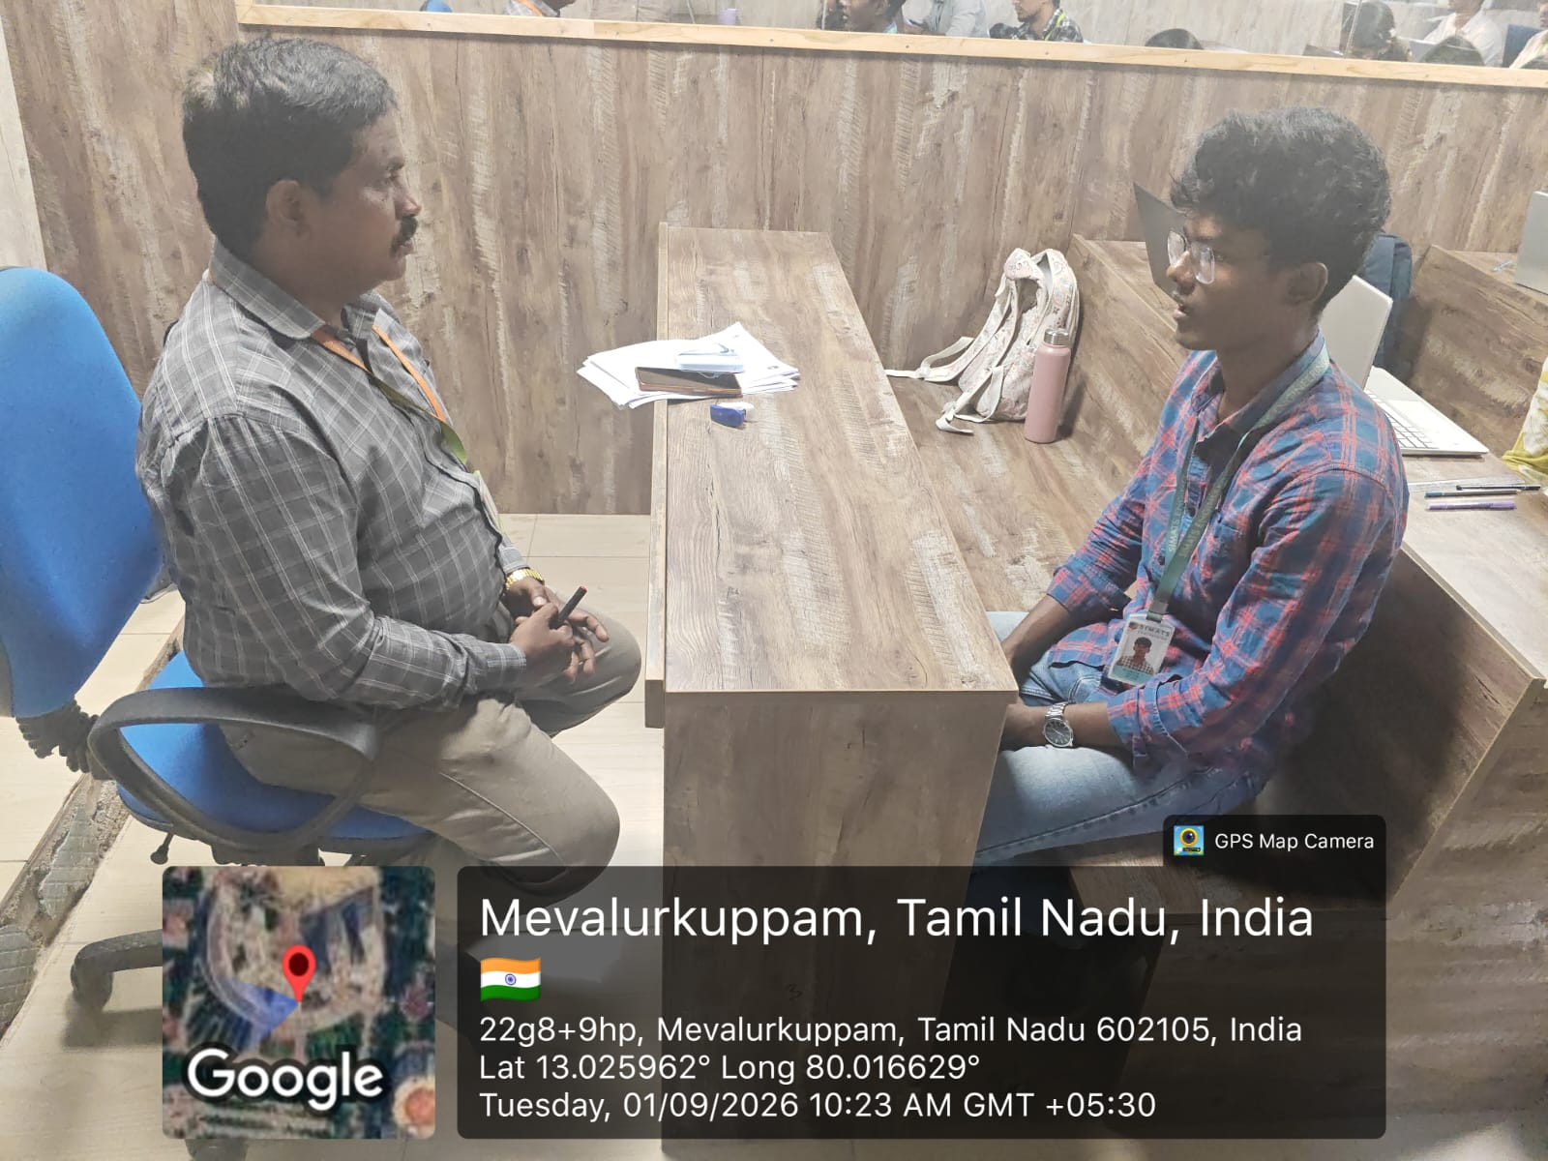

RUBRICS FOR CALCULATION:
MOCK INTERVIEW

Criteria | Weightage | Level 4 (Exemplary) | Level 3 (Proficient) | Level 2 (Developing) | Level 1 (Beginning)
Technical Knowledge | 25 | Demonstrates strong and accurate subject knowledge with in-depth understanding | Shows good knowledge with minor gaps | Basic knowledge with noticeable errors | Lacks fundamental technical knowledge
Problem Solving | 25 | Solves problems logically and applies concepts effectively in real scenarios | Applies concepts with moderate accuracy | Limited problem-solving ability; requires guidance | Unable to solve or apply concepts
Analytical Thinking | 15 | Analyzes questions critically and provides well-structured, logical answers | Provides reasonable analysis with some structure | Superficial or partially structured responses | No analytical thinking demonstrated
Communication | 15 | Communicates clearly, confidently, and professionally with proper terminology | Communicates well with minor hesitation | Communication lacks clarity or confidence | Unable to communicate effectively
Confidence | 15 | Displays high confidence, positive attitude, and professional behavior throughout | Shows good confidence with minor issues | Low confidence; inconsistent behavior | Lacks confidence and professionalism
Response to Questions | 10 | Responds accurately, promptly, and elaborates with relevant examples | Responds correctly but with limited depth | Partial responses; needs prompting | Unable to respond appropriately

